**ST. THEREZA NAMILYANGO GIRLS’ PRIMARY SCHOOL**

**END OF TERM I CONTINUOUS ASSESSMENT 2024**

**P.7 MATHEMATICS**

***Time Allowed: 2 Hours 30 Minutes***



**Candidate’s Name: _________________________________________________**

**Candidate’s Signature: ______________________________________________**

**District Name: _____________________________________________________**

**SECTION A (40 marks)**

1. Sum up 114 and 25 .

2. Write **forty-four thousand four hundred four** in figures .

3. Solve: x – 5 6 (finite 7)

4. Find the square of 1 .

5. Find the length of side BD in the figure below given that

BE $=$ 6cm , AC $=$ 8cm and AD $=$ 12cm .

A

12cm

8cm

E

6cm

C

B D

6. With the help of a pair of compasses, a ruler and a sharp pencil only, construct an angle of 1350 .

7. Simplify: 8x 2x2 6x 7x2

8. How many 1 $\frac{1}{4}$ kg packets can be got from a 25kg bag ?

9. Express 36km/h in m/sec .

10. The meeting which lasted 2 $\frac{1}{2}$ hours ended at the time shown on the clock face below .

At what time did the meeting start ?

[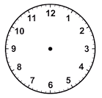](http://www.google.co.ug/url?q=https://impremedia.net/image-of-wall-clock-without-hands/&sa=U&ved=0ahUKEwi5-_TAqY_bAhXrDcAKHYBLBMIQwW4IHTAE&usg=AOvVaw0QB0dUBHMA7bHK5C7S8umq)

11. It is 11:25a.m. now, what time will it be after 45 hours ?

12. Write 5020**.**7 in standard form .

13. Kato removed $\frac{1}{3}$ from a number and was left with $\frac{5}{12}$. Find the number .

14. A number is exactly divisible by four but when it is divided by 5 , 2 remains . What is the number ?

15. Calculate the value of k in the figure below .

(5k30)0

(2k21)0

16. In a queue, Jane is the 8th from one side and the 7th from the other side. How many girls are queuing ?

17. Shade (A $-$ B)c on the Venn diagram below .

A B

18. The exterior angle of a regular polygon is 400. Name the polygon.

19. Martina bought a wrist watch at sh. 44,000 and later sold it making a 10% profit. For how much did she sell the wrist watch?

20. Solve for m : 2m 1 $=$ 31

**SECTION B (60 MARKS)**

21. The Venn diagram below shows the number of pupils who took part in sports activities i.e. track events (T) and field events (F). Use it to answer the questions about it.

n(E) $=$………

n(T) $=$ n(F) $=$

r $+$ 5 r 2r $+$ 15

r $-$ 5

1. Given that 50 pupils like only one kind of event, find the value of r. (2 marks)

(b) Find the probability of choosing a pupil at random who participated in field events to be a captain. (3 marks)

22(a) Simplify: 1**.**6 $×$ 2**.**7 (3 marks)

0**.**04 $×$ 0**.**9

(b) Express 0**.**7272 . . . as a simplified vulgar fraction.

(2 marks)

23(a) Work out: 430six 24six (2 marks)

(b) Find the value of n if 102n 18six (3 marks)

24. The median of four consecutive odd numbers is 26. If the smallest is m,

(a) find value of m . (3 marks)

(b) Find the product of the second and the fourth numbers .

(3 marks)

25. The table below shows Mrs. Konge’s shopping bill. Use it to answer the questions that follow.

|  |  |  |  |
| --- | --- | --- | --- |
| **Item** | **Quantity** | **Unit Cost** | **Amount** |
| Beans | 3 kg | sh. 4,000 per kg | sh. |
| Maize flour | kg | sh. 1,800 per kg | sh. 4,500 |
| Salt | 600 g | sh. per kg | sh. 900 |
| **Total expenditure** | | | |

V

Complete the table. (Show the working) (4 marks)

26. A truck driver left town **A** for town **B** at 8:00 a.m. driving at a steady speed of 66km/h and reached town **B** at 10:30a.m. He rested for one hour then continued to town **C**, 160km from **B** in 1 hour 30minutes.

(a) How far is town **B** from town **A** ? (3 marks)

(b) Calculate the average speed for the entire journey . (2 marks)

27. Use the figure below to answer the questions that follow .

R

P

(2w $+$ 1)dm

(w $+$ 7)dm

h

Q

10dm

(a) Find the value of w . (2 marks)

(b) Calculate the area of the above figure . (4 marks)

28. Matilda got a loan of sh. 1,200,000 from Finance Trust Bank which charges a simple interest rate of 5 $\frac{1}{2}$% per annum for 2 $\frac{1}{2}$ years .

(a) Calculate the interest she paid at the end of the given period.

(3 marks)

(b) How much money did she pay back altogether? (2 marks)

31. Below is a rectangular tank which is $\frac{2}{3}$ full . Use it to answer the questions that follow.

h

50cm

40cm

60cm

1. Calculate the value of h . (2 marks)

(b) Work out the capacity of the tank in litres when full. (3 marks)

29. Use the number line below to answer the questions that follow.

a

b

c

(a) Write the integer represented by arrow ; (1 mark @)

a $=$________ b $=$________ c $=$

________

(b) Write the mathematical statement for the above number line.

(2 marks)

30(a) Using a pair of compasses, a ruler and a sharp pencil only, construct triangle BED where BE $=$ 6cm , angle BED 450 and

(4 marks)

ED $=$ 10cm .

**32. The graph below shows how a motorist travelled from town M to town R through N. Use it to answer the questions that follow.**

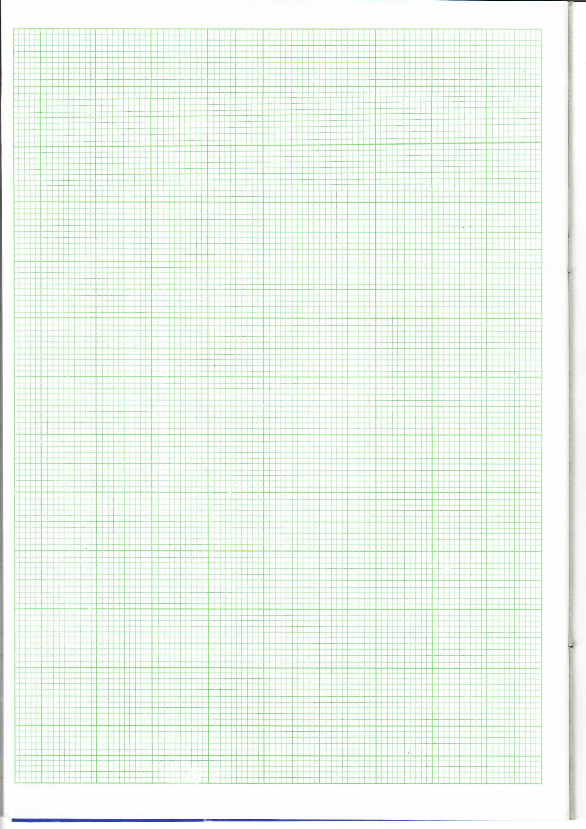

3p.m

2p.m

1p.m.

12noon

11a.m.

9a.m.

10a.m.

8a.m.

Town **R**

Town **M**

Town **N**

60

50

40

30

20

0

10

***Distance in km***

**Time in hours**

(a) What is the scale on the vertical axis ? (1 mark)

(b) At what speed did the motorist move between towns **M** and **N** ?

(1 mark)

(c) Find the total time the motorist took while moving.

(2 marks)

**END**